RESUME

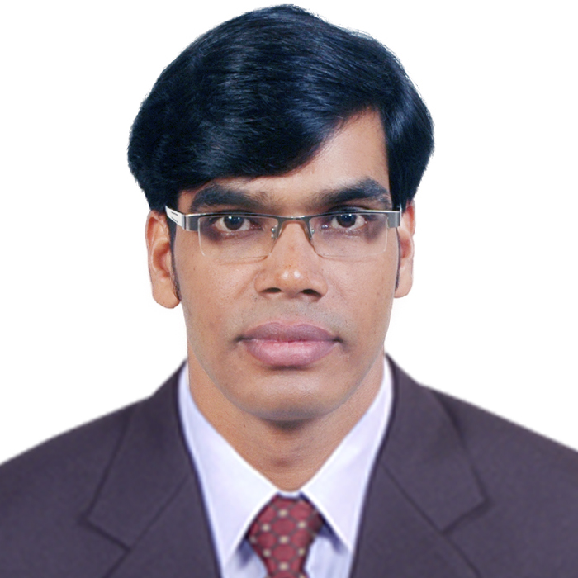
AMARESH MOHANTY.

C/o:- Bimbadhar Mohanty.

At: - Patapur.

Po/Dist: - Jajpur.

ORISSA

Pin.755001

Cell-9853003893.
Mail: - amuamaresh@gmail.com.
amaresh.online@yahoo.co.in

Career Objective:

To work in sincerity in a dynamic slab and secure a position in a team oriented organization where my knowledge, experience and ideas would be valued and my professional growth would be hastened up.

Present Employment Status :
- Working as a manager key accounts at M/s Terminix sis india pvt ltd.

- Records of previous employment’s
Working as a Customer services Executive (CSE) at PCI Pest Control Pvt. Ltd. (PCI) Bhubaneswar,Orissa from 2013 Apr’ to may 2021.

Working as an Back Office Executive at ARYA, Auth. Distributor for Mediapro enterprise india pvt ltd. (India’s No.1 Television Network) for Orissa from 2010 May10 to 2013 March 31.

- Worked for M/s SATCO Auth. Distributor for (STAR Den Media Pvt), Bhubaneswar from Jan 01 2009 to Apr’ 30 2010.
- Worked for M/s Mohapatra Brothers distributor in (AIRTEL), Jajpur from Sep 2006 to Dec’ 2008.
- Worked as a data entry operator in Silicon info sis, Jajpur Centre from Aug 2003 to Jan 2005

Computer Proficiency:-
- Post Graduate Diploma in Computer Application.
PGDCA (Microsis InfoTech Computer Education)
- Computer Hardware & Maintenance
SEEHURD
(Society for Entrepreneurship Environment & Human Resources Development)
Educational Qualification:-

- B.Com from Utkal University.
- I.Com from. Council of higher Secondary Education Orissa.
- HSC from Board of Secondary Education, Orissa.

Extra Curricular:-Animation

Awards:-
- Silver Medalist in “Group Dance Competition and Solo Dance” at Raja Mahachaba-2000.
- “Best Actor” in the District Youth Festival, Jajpur (Mangalpur).
- “Best Designer” in the District Youth Festival, Jajpur (mangalpur).

Hobbies:- Acting, Art, dance. Social works.
Personal Profile:-

Father’s Name : - Mr. Bimbadhar Mohanty.
Date of Birth : - 30th Dec 1981
Nationality : - Indian
Sex : - Male
Marital Status : - Married
Language Known : - Oriya, Hindi & English.
Present Address : - 1345/11878
Satys Bihar,rasulgarh
Bhubaneswar.
Dist- Khurda.
Orissa.
Pin – 751010.

Date :- 18/ 01 /2021.
Place :-Bhubaneswar
( Amaresh Mohanty )

