RESUME

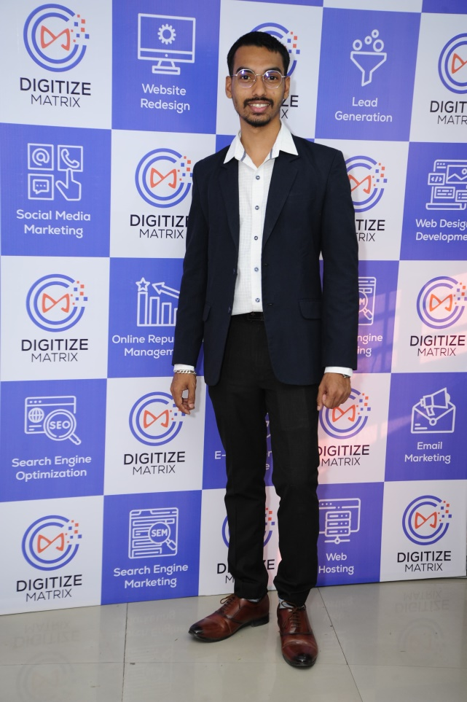

# Shubham Rahul Apre

Bhistabag, Ahmednagar, 414003.

**Phone:** +91 8855920943. [**Email:**shubhamapre46@gmail.com](mailto:shubhamapre46@gmail.com)

**Career Objective:** To obtain a full time position where I would consider myself perfect, where I can utilize my skills to make a significant contribution to the success of the company and at the same time I can learn and develop myself.

# Educational Qualification:

|  |  |  |  |  |
| --- | --- | --- | --- | --- |
| **Course** | **Institution** | **University** | **Year Of Completion** | **Class** |
| TY(BCS) | New Arts, Commerce and Science college, Ahmednagar | Pune | 2017-18 | **Higher Second Class** |
| SY(BCS) | New Arts, Commerce and Science college, Ahmednagar | Pune | 2016-17 | **Higher Second Class** |
| FY(BCS) | New Arts, Commerce and Science college, Ahmednagar | Pune | 2015-16 | **Higher Second Class** |
| HSC | Shahid Vithal Bhalsing junior college, Ahmednagar | Pune | 2015 | **First Class** |
| SSC | Keshavrao Gadilkar High School Ahmednagar | Pune | 2013 | **First Class** |

**Certification:**

* HARDWARE Completed with A grade from IACT institute, Ahmednagar.
* Programming in HTML, CSS, Bootstrap, C, C++, JavaScript and PHP
* Graphic Design.

# Live Own Projects:

( <https://www.moryadukan.com/> ) This Is My Own shop live website

# Work Experience:

* Worked as a Sales Executive in LIC for 8 months.
* Worked as a Web Developer for 6 months at ShopCon.
* Worked as a Web Developer for 3 months at CorWin Minds.
* Worked as a Web Developer for 6 months at TVD Software.
* 1 Years working experience in Graphic Designer in my own Moray Studio.
* 1.2 Years work experience in Digitize Matrix Company as UI/Web Developer.

# Extracurricular Activates:

* Draw name in Ganapati.
* DIY craft designing

# Technical Skills:

* HTML5, CSS3, Bootstrap, JAVASCRIPT, Advance PHP, SQL
* Basic SEO Knowledge
* Use of tools – Gtmetrix Bloggingos & seoquack.
* Hardware
* Graphic Designing

**Strength:**

* To achieve new things
* Hard Working

# Personal Details:

**Name :** Shubham Rahul Apre.

**Address :** Bhistabag, Ahmednagar 414003.

**DOB :** 30/9/ 1997.

**Gender :** Male.

**Nationality :** Indian.

**Marital status :** Unmarried.

**Languages Known :** English(Optional), Hindi and Marathi.

**Hobbies** : Drawing, Watching realistic movie, travelling

I, hereby declare that the given information is true to the best of my knowledge.

# 

Date: / / 2024  
   
   
 **(Shubham Apre)**